Stock Price Movement Prediction Using Hybrid LSTM-Transformer Models

Introduction

Broad Context
Forecasting stock prices is difficult because they are volatile, non-linear and sensitive to events in the global economy [1].Traditional statistical models do not effectively capture complex time dependencies in financial time-series data. Deep learning models can be useful to model short-term sequence patterns by applying Long Short-Term Memory (LSTM) networks, whereas Transformer architectures can learn long-range dependencies with the help of self-attention [2]. The proposed hybrid system of LSTM-Transformer is thus potentially beneficial in the integration of sequence-based memory learning with the global contextual modelling. This project aims at predicting stock price movement by using historical market data such as S&P 500 data or NASDAQ data with effective technical indicators to increase the reliability of the prediction.
Prediction of the stock movement is always a challenging task due to the high noise in financial markets, exposure to external factors and sudden movements. Individual deep learning networks typically struggle to capture both short-run and long-run effects at the same time. The limitation has an impact on the accuracy of forecasts and trading decisions, financial risk assessment and investment strategy development. To enhance the predictive performance, a hybrid LSTM-Transformer model can be used, where there is a combination of both sequential and contextual learning.

Research Gap
The current literature uses LSTM or Transformer separately. Limited research can assess the hybrid structures with enhanced financial measures to make strong forecasts of stock movement.

Solutions and Contribution

Aim:
This research seeks to create a hybrid LSTM-Transformer deep learning model to forecast the movement of stock prices based on historical financial time-series data.

Objectives:
- To preprocess stock data of NASDAQ or S&P 500 and compute technical indicators such as moving averages, RSI and volatility indicators.
- To design a hybrid deep learning architecture that involves LSTM sequential encoding with Transformer attention layers.
- To compare predictive performance using such metrics as RMSE, directional accuracy and F1-score with the standalone LSTM or Transformer models.
- To test the stability of models in unstable market environments and determine the consistency of forecasting.

Contribution:
- Hybrid LSTM-Transformer forecasting model development.
- A combination of technical indicators and stock prices.
- Relative analysis with control models.
- Experiential knowledge on financial time-series forecasting.

Report Outline
It contains an introduction, literature review, methodology, results, discussion and conclusion that explain the model development, evaluation and results involving stock price prediction.

Literature Review

Financial Time-Series Data Preparation and Feature Engineering
Strong data preprocessing and feature engineering are essential to successful stock market prediction because financial series data are usually noisy, volatile and depend on various factors. Usmani, et al., (2024) mentioned that the problem can be addressed within the Preptimize framework, which proves that automated preprocessing pipelines have the potential to enhance the consistency of forecasting, systematically handling the missing data, scaling and time alignment [3]. However, automation will reduce efficiency, it can fail to capture domain-specificity like market anomalies or structural breaks.
On the same note, Li and Shi (2024) focus on hybrid preprocessing techniques that involve the combination of statistical filtering and neural-network-based transformation [4]. Their results indicate that the use of various preprocessing methods increases predictive stability, especially when using a neural model. This aligns with the point of Wei, et al., (2024), who state that feature extraction has a substantial effect on deep learning in the case of stock prediction [5]. They show that optimised feature sets result in better convergence of the model, but their analysis is more concerned with the convergence of optimisation results, rather than on the interpretability of engineered features.
Another dimension that is important is feature selection. According to Htun, et al., (2023), there is a general survey of inappropriate feature selection, which leads to low predictability, even with sophisticated modelling models [6]. Their discussion agrees with the point that preprocessing quality can be a more important determinant of predictive success than model complexity. Mostafavi and Hooman (2025) concentrate on the technical indicators, which are trend, volatility and momentum measures that they name as the important sources of the prediction accuracy [7]. Although their results confirm the usefulness of traditional indicators, critics report the possibility of redundancy of indicators which can create multicollinearity.
Continuing this point, Li, et al., (2025) combine various technical indicators with convolutional neural networks and show that they outperform traditional predictive models by using engineered feature inputs [8]. Their study supports the argument put forward by Htun, et al., (2023) on feature significance, but they also show doubts over overfitting when many indicators are included without strict selection [6].
The Literature can be concluded that preprocessing and feature engineering are the keys to the success of stock prediction. However, there are controversies about automation versus domain-informed preprocessing, optimum indication choice and manipulating feature richness against model generalisation.

Deep Learning Architectures for Stock Market Prediction
Financial time-series forecasting has become a growing area of application of deep learning structures owing to their capability of modelling non-linear relationships and time-related axioms in stock market data. Long Short-Term Memory (LSTM) networks have continued to be highly used due to their application to sequential patterns. The results presented by Zaheer, et al., (2023) indicate that stock prediction accuracy can be significantly enhanced when using a multi-parameter LSTM model and various financial indicators and thus, the value of the sequential memory learning [9]. However, the LSTM models are sometimes ineffective in capturing long-range dependencies and the wider contextual interactions, even with their strengths.
In order to deal with these shortcomings, recurrent architectures have been combined with attention mechanisms. Wen and Li (2023) suggest an LSTM-attention-LSTM model, which improves the predictability by selectively emphasising the time-series features [10]. Based on their results they hypothesise that feature representation is enhanced by attention and this should not be confused with increased overfitting and computational requirements associated with greater architectural complexity in situations where data quality is not even.
Further recent studies have shifted to Transformer-based systems, which are purely based on self-attention systems. The study of Chen, et al., (2025) presents the Enhanced Multi-Aspect Attention Transformer (EMAT), which approaches financial forecasting with better performance because it identifies numerous temporal relationships at the same time [11]. On the same note, Li and Xu (2025) integrate the generative adversarial network with the Transformer-based attention mechanisms based on the argument that hybrid structures increase predictive strength and adaptability in dynamic market situations [12]. Although these models promise strong results in the improvement of accuracy, critics raise issues on interpretability and excessive computational demands.
Based on these studies, there has been a focus on hybrid LSTM and Transformer architectures. The model suggested by Kabir, et al., (2025) is a strong combination of LSTM and Transformer that combines the sequential memory feature with contextual learning that relies on attention [13]. These findings suggest that hybrid architectures have the capacity to compromise local sequential learning with global contextual knowledge and this argument holds since they have stronger stability in their forecasts than standalone.
The literature shows that it is possible to observe the strict transformation of classical LSTM models into attention-enhanced and hybrid ones. Although the hybrid models have a high potential for financial forecasting, there still exist issues of complexity, interpretability and cost of computing the model and therefore empirical analysis and optimisation are necessary.

Performance Evaluation and Model Reliability in Stock Market Prediction
The analysis of predictive model performance and reliability of stock market forecasting is an important part of financial forecasting because financial time-series data is highly volatile, noisy, and non-stationary. According to Sonkavde, et al., (2023), model assessment should go beyond the traditional accuracy-related measures by introducing the concepts of robustness, generalisability, and practical applicability [14]. They claim that the commonly used measures such as RMSE, MAE and accuracy alone, are inadequate since they do not represent directional correctness, which plays a significant role in trading decisions in the real world. This weakness points out a critical problem in financial forecasting studies where financial models can have low error rates but still can be very ineffective in market trend forecasting.
Comparative studies also show that it can be complicated to evaluate deep learning models. In their work, Osman and Otaibi (2025) compare LSTM, Transformer, and traditional econometric models in general and find that, despite the general superiority of deep learning models to classical ones, the new models do not perform equally well in all datasets and evaluation metrics [15]. Liu (2026) arrives at a similar conclusion that Transformer-based models are particularly effective in comprehending long-range dependencies with the assistance of attention mechanisms [16]. All these findings are problematic to the general assumption that more sophisticated architectures are necessarily more predictive performing, and that model effectiveness is very context dependent.
The benchmarking research supports the significance of multi-dimensional assessment systems. Wilham and Manalu (2025) note that deep learning models, despite having a higher predictive accuracy in comparison with other models, are not very interpretable and can require large volumes of computation, which in practice preclude their applicability in real-time financial systems [17]. Ampountolas (2023) then builds on this argument with a comparison of machine learning, deep learning and hybrid models, showing that hybrid models often have more consistent and stable performance in various financial markets [18]. This refers to the fact that reliability is not only a question of accuracy but also a pattern to test its functionality in relation to various market conditions and data distributions.
There are also important obstacles to model generalisation that are found in the empirical evidence. In a study by Alam, et al., (2024), when experiments were conducted on 26 real-world datasets, it was demonstrated that the performance of models differs significantly among the market environments, which suggests that models trained on datasets might not be effective at generalising their results [19]. Kyriakou, et al., (2021) confirm this observation, stating that the cross-temporal and multi-dataset benchmarking is a crucial tool that should be used to evaluate the reliability of long-term predictions [20]. They state that short-term predictive success is not necessarily sustainable performance, particularly in a volatile financial market.
Overall, the literature highlights the multi-dimensional approach, which must be taken to evaluate the effectiveness of stock market prediction models based on the accuracy, robustness, consistency, and interpretability. Although deep learning and hybrid models are shown to have high predictive performance, their reliability depends on the right evaluation strategy, diversity in the datasets, and correlation with the reality of financial goals. Further studies are mandatory to create standard benchmarking models and include risk-sensitive assessment measures to increase the practical usefulness of the financial forecasting models.

Research Gap
Despite of the extensive research on the topic of stock market prediction, there are important gaps. Various papers focus on preprocessing, model architecture, and evaluation individually, but not much has been done on integrating these elements. The hybrid LSTM-Transformer models have potential, but a lack of evidence of their operation with engineered financial characteristics in different market conditions exists. Moreover, there is a lack of consistency in the evaluation practices that tend to be based on narrow metrics and data sets. This shows the necessity of a unified solution to effective preprocessing, hybrid modelling, and overall evaluation to have strong stock prediction.

Methodology

Dataset and Preprocessing
The study uses historical data on the stock market of Yahoo Finance through the yfinance API and the SPY ETF as a proxy of the S&P 500 index. The data range will be January 2010 to January 2025, and it will contain a daily Open, High, Low, Close, and Volume values. Following cleaning and sorting, 3,774 observations were left. Missing values were eliminated to guarantee data consistency.
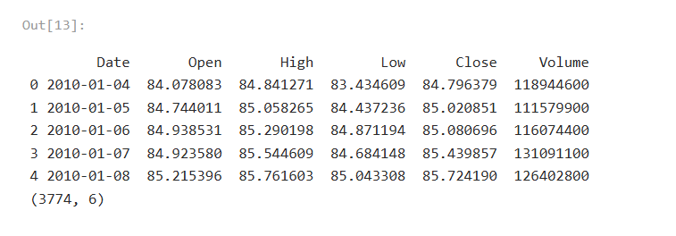
Figure 1: Dataset Description
Many feature engineering techniques were used to improve predictive capacity. Price-related characteristics, including multi-horizon returns (1, 3, 5, and 10 days), price gaps, and volatility indicators, were obtained. Also, such technical indicators as Simple and Exponential Moving Averages (SMA, EMA), Relative Strength Index (RSI), Stochastic Oscillator, Moving Average Convergence Divergence (MACD), Bollinger Bands and Average True Range (ATR) were added. These properties record the short-term variations as well as the long-term market patterns [21].
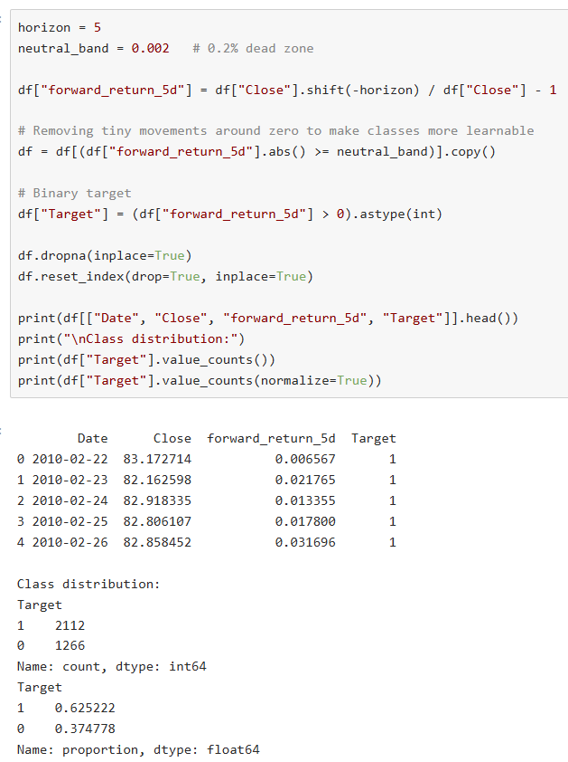
Figure 2: Target Creation
A 5-day forward return was used to define a binary target variable. A neutral threshold of +-0.2% was used to eliminate the insignificant movements to reduce the noise and enhance the separation of classes.
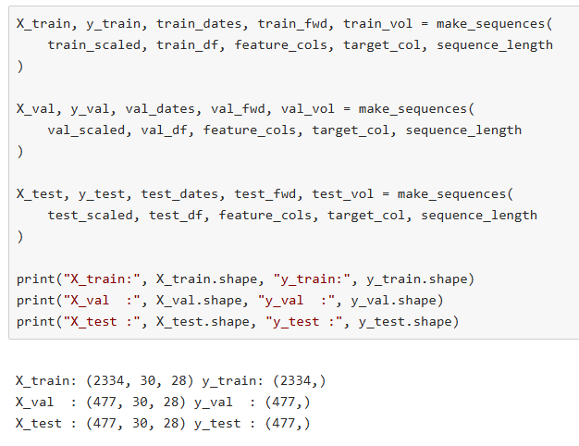
Figure 3: Dataset Split
To avoid data leakage, the dataset was chronologically divided into training (70%), validation (15%), and test (15) sets. The feature scaling in training data was done using StandardScaler and was applied to each subset. Temporal learning was then enabled by the creation of time-series sequences of 30 days.

Model Architectures
There were three implemented deep learning models, including the LSTM, the Transformer and a hybrid LSTM-Transformer model.
The LSTM model is appropriate for modelling short-term temporal patterns as it considers a sequence of dependencies based on recurrent memory units [22]. Conversely, the Transformer model employs multi-head self-attention coupled with positional encoding to acquire long-range and multifaceted temporal relationships.
The hybrid model suggested combines the two approaches. It does the sequence processing in two stages using LSTM layers to learn local time-related dynamics, and a Transformer encoder to learn global contextual dependency. It is composed of a projection layer, positional encoding, and fully connected layers, which are provided with ReLU activation. This structure takes the place of the shortcomings of single models with the integration of sequential and attention-based learning.

Training and Implementation Details
Models were run in PyTorch and the reproducibility of the model was guaranteed by setting random seeds. The AdamW optimiser used to conduct the training was set with a learning rate of 0.0005 and a weight decay of 1e-4, to minimise overfitting.
The maximum number of epochs was 40 and the batch size was 32. Validation loss early stopping prevented overfitting and the ReduceLROnPlateau scheduler automatically reduced the learning rates. Gradient clipping was used to stabilise training (max norm = 1.0).
In solving class imbalance, weighted cross-entropy loss was implemented with class weights based on training data, which allowed balanced class learning.

Evaluation Metrics
Accuracy, Balanced Accuracy, Macro F1-score, weighted F1-score and ROC-AUC were used to measure model performance. Macro F1-score was chosen because it is competitive in the presence of class imbalance [23].
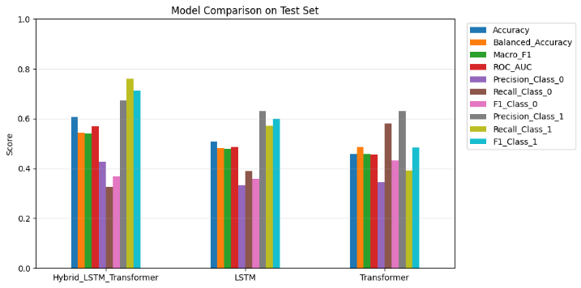
Figure 4: Model performance comparision
The decision thresholds were optimised using validation data to optimise the macro F1-score and improve the classification performance. In confusion matrices and classification reports, detailed information was described.
To measure practical reliability, models were further tested in conditions of high volatility, which made it possible to test the stability of performance in volatile financial conditions.

References

[1] | M. A. Khan, H. Ali, H. Shabbir, F. Noor and M. D. Majid, “Impact of macroeconomic indicators on stock market predictions: A cross country analysis,” Journal of Computing & Biomedical Informatics, vol. 8, no. 01, 2024.
[2] | D. Sachar, “Time series forecasting using deep learning: a comparative study of LSTM, GRU, and transformer models,” Journal of Computer Science and Technology Studies, vol. 5, no. 1, pp. 74-89, 2023.
[3] | M. Usmani, Z. A. Memon, A. Zulfiqar and R. Qureshi, “Preptimize: Automation of time series data preprocessing and forecasting,” Algorithms, vol. 17, no. 8, p. 332, 2024.
[4] | J. L. Li and W. K. Shi, “Hybrid preprocessing for neural network-based stock price prediction,” Heliyon, vol. 10, no. 24, 2024.
[5] | Y. Wei, X. Gu, Z. Feng, Z. Li and M. Sun, “Feature extraction and model optimization of deep learning in stock market prediction,” Journal of Computer Technology and Software, vol. 3, no. 4, 2024.
[6] | H. H. Htun, M. Biehl and N. Petkov, “Survey of feature selection and extraction techniques for stock market prediction,” Financial Innovation, vol. 9, no. 1, p. 26, 2023.
[7] | S. M. Mostafavi and A. R. Hooman, “Key technical indicators for stock market prediction,” Machine Learning with Applications, vol. 20, p. 100631, 2025.
[8] | W. Li, L. Whang and X. Zhang, “Predicting Multi-Indicator Stock Time Series using Convolutional Neural Networks based on Feature Engineering,” International Journal of Computers Communications & Control, vol. 20, no. 5, 2025.
[9] | S. Zaheer, N. Anjum, S. Hussain, A. D. Algarni, J. Iqbal, S. Bourouis and S. S. Ullah, “A multi parameter forecasting for stock time series data using LSTM and deep learning model,” Mathematics, vol. 11, no. 3, p. 590, 2023.
[10] | X. Wen and W. Li, “Time series prediction based on LSTM-attention-LSTM model,” IEEE access, vol. 11, pp. 48322-48331, 2023.
[11] | Y. Chen, W. Shen, H. Liu and X. Cao, “EMAT: Enhanced multi-aspect attention transformer for financial time series forecasting,” Entropy, vol. 27, no. 10, p. 1029, 2025.
[12] | S. Li and S. Xu, “Enhancing stock price prediction using GANs and transformer-based attention mechanisms,” Empirical Economics, vol. 68, no. 1, pp. 373-403, 2025.
[13] | M. R. Kabir, D. Bhadra, M. Ridoy and M. Milanova, “LSTM–transformer-based robust hybrid deep learning model for financial time series forecasting,” Sci, vol. 7, no. 1, p. 7, 2025.
[14] | G. Sonkavde, D. S. Dharrao, A. M. Bongale, S. T. Deokate, D. Doreswamy and S. K. Bhat, “Forecasting stock market prices using machine learning and deep learning models: A systematic review, performance analysis and discussion of implications,” International Journal of Financial Studies, vol. 11, no. 3, p. 94, 2023.
[15] | E. G. Osman and F. A. Otaibi, “Integrating deep learning and econometrics for stock price prediction: A comprehensive comparison of lstm, transformers, and traditional time series models,” Machine Learning with Applications, p. 100730, 2025.
[16] | T. Liu, “A Comparative Study of Transformer-Based and Classical Models for Financial Time-Series Forecasting,” Journal of Risk and Financial Management, vol. 19, no. 3, p. 203, 2026.
[17] | A. K. Wilham and S. R. Manalu, “Stocks and models: A comparative benchmark of machine learning and deep learning approaches for stock market prediction,” Procedia Computer Science, vol. 269, pp. 1532-1545, 2025.
[18] | A. Ampountolas, “Comparative analysis of machine learning, hybrid, and deep learning forecasting models: evidence from European financial markets and bitcoins,” Forecasting, vol. 5, no. 2, pp. 472-486, 2023.
[19] | K. Alam, M. H. Bhuiyan, I. U. Haque, M. F. Monir and T. Ahmed, “Enhancing stock market prediction: A robust LSTM-DNN model analysis on 26 real-life datasets,” IEEE Access, vol. 12, pp. 122757-122768, 2024.
[20] | I. Kyriakou, P. Mousavi, J. P. Nielsen and M. Scholz, “Forecasting benchmarks of long-term stock returns via machine learning,” Annals of Operations Research, vol. 297, no. 1, pp. 221-240, 2021.
[21] | A. K. Bhagat and V. K. Jain, “Evaluating Predictive Power of Fundamental and Technical Indicators Using Machine Learning in Commodity Markets,” International Journal of Advanced Research and Multidisciplinary Trends (IJARMT), vol. 2, no. 3, pp. 973-992, 2025.
[22] | B. Lindemann, T. Müller, H. Vietz, N. Jazdi and M. Weyrich, “A survey on long short-term memory networks for time series prediction,” Procedia Cirp, vol. 99, pp. 650-655, 2021.
[23] | S. Riyanto, S. S. Imas, T. Djatna and T. D. Atikah, “Comparative analysis using various performance metrics in imbalanced data for multi-class text classification,” International Journal of Advanced Computer Science and Applications, vol. 14, no. 6, 2023.

